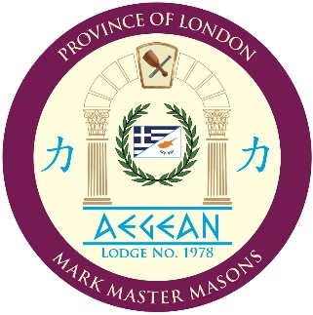

MENU FOR TUESDAY 26TH MARCH 2019

Selection of Greek Meze Starters
***
Traditional Greek Lamb Kleftiko with Cyprus Roast Potatoes & Greek Village Salad

***
Traditional Greek Cake
***
Tea or Coffee served with Greek Lokoumia

The charge for dining at this Meeting is a £50 (inclusive of wine). Please complete and return this slip to the Assistant Secretary, W. Bro Marios Stylianides, by Friday 15th March 2019, whether or not you are attending / dining. Contact details are provided below:

An email will also be most helpful if you are tendering your apologies in order that they may be recorded.

AEGEAN LODGE of MARK MASTER MASONS No. 1978

Your Name ………………..…………………………..…..……………………………..….……

I shall be attending the Meeting Yes / No and will/will not have guest(s) attending with me.

I shall be dining Yes / No and so shall my...... guest(s) at £50 per head.

 | Title | Name | Rank | Dietary Requirements
Member
Guest
Guest
Guest

Alternative vegetarian meals or other dietary requirements can be catered for if pre-booked by the 15th March 2019.
Unfortunately, amendments cannot be made on the day.

Please email or post to: Marios Stylianides, The Island, Church Street, Rickmansworth, Herts, WD23 1JJ
E-mail - marios.s@btconnect.com

EITHER: I enclose my cheque, made payable to Aegean Lodge No. 1978, for £ ..................

OR I have transferred £...50............ directly to the Lodge bank account

National Westminster (Rickmansworth) - Sort Code 60-17-32 Account No. 10658971

